Kyle Rodriguez

February 21st, 2020

Foundations of Programming: Python

Assignment 05

# Task List Script

# Introduction:

Assignment number 5 brings new challenges with reading and writing to a data file. Adding the functionality to remove rows gives the user more options and power to manage the data. The program also utilizes the computer’s memory to hold the current state of data before writing to the file and saving. This gives the user the option to view current changes and not save them if they want. For the scope of this program the data being held in memory does not carry large risk but larger data sets risk slowing down the computer as well as chances for data loss if the user does not explicitly save the program. Programs handling large amounts of data will often write to the data layer on a more consistent basis to avoid data loss or throttling the computer or servers RAM.

# My Script:

# Script Observations:

The script begins by calling the function read_file() which reads the csv data file and returns a list table (lstTable) to be used as the main data variable for the program. This initial load is called only once and the other functions used in the program are dependent on a successful read_file() run. When the user selects menu item 1, the current_data() function is called passing in the lstTable to be looped through and made into a dictionary of Task and Priority pairs. The dictionary is then printed out to the user line by line to be easily read. When the user selects menu item 2, the add_task() function is called by passing in the lstTable and prompting the user to enter a new task and priority to be appended to the tblList. When adding a task, it is important to strip any leading and trailing spaces to avoid potential errors relevant to carriage returns. When selecting menu item 3, the rem_task() function will print out the current tasks in the lstTable and prompt the user to enter a task they would like to remove. After selecting the task, the rem_task() will then loop through and using an if conditional will remove the row that contains the selected task. Selecting the option menu 4 will call save_data() that opens the file location in write mode before looping through the lstTable and printing back into the txt file the updated changes.

# Script in Action

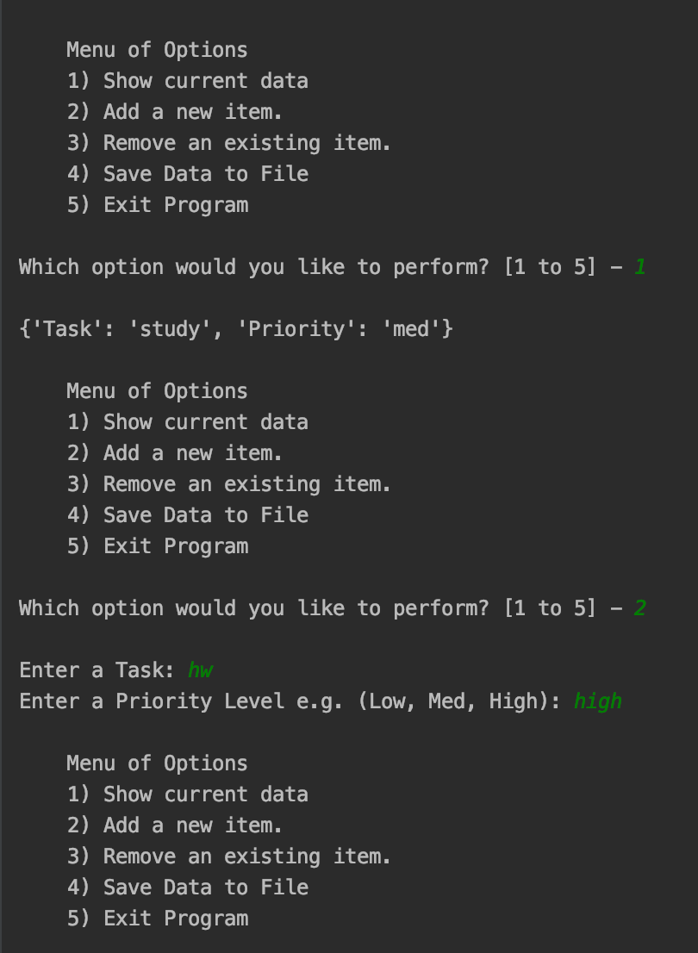

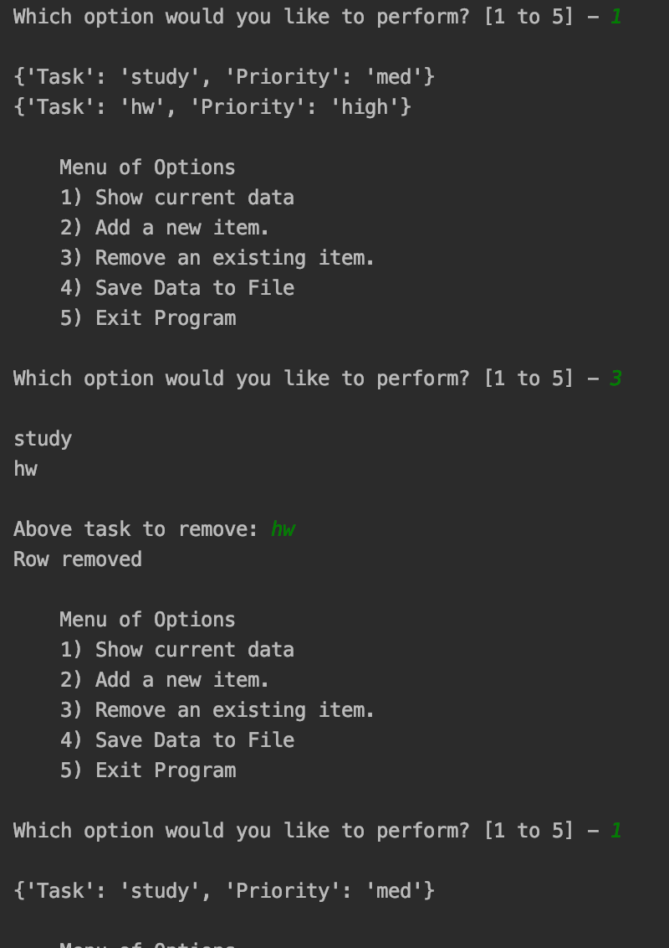

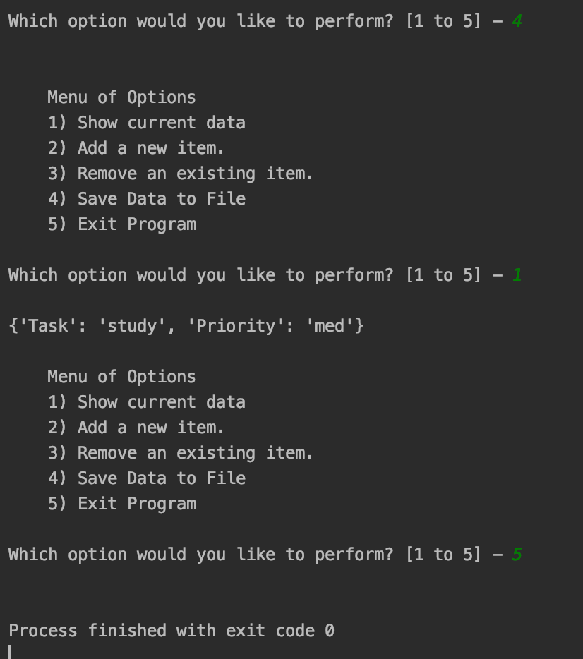

# Summary

Through this assignment I became much more familiar with debugging and how it can help me better understand issues in my code as well as how to fix them. I ran into a few issues with leading spaces and carriage returns that I would not have been able to find easily without stepping through the program in debug mode. Another way to debug that helped me was to include print statements of my lstTable throughout the defined functions so I could see how lstTable changed as I entered more and more menu option commands and data. A major bug that I found in my original code involved a new line character that was being printed to the file and when parsing through on the programs rerun it would fail because split was expecting a comma. I eventually found that the issue was in my initial load had an extra carriage return and using strip() I was able to resolve the defect without effecting any of my formatting.